**1. Databases**

Hello and welcome! My name is Izzy Weber, and I will be your SQL coach.

**2. Course goals**

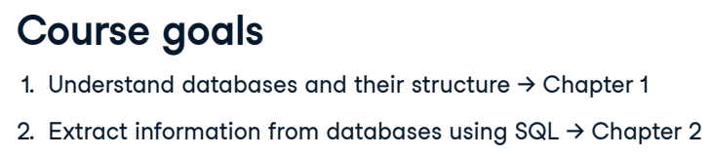

We have two main goals in this course. In Chapter One, we will get to know databases, which store and organize data electronically. We'll discuss how databases and the data they store are structured. This context will prepare us for our second goal: to extract data from databases using SQL code in Chapter Two. Let's dive in!

**3. Introducing databases**

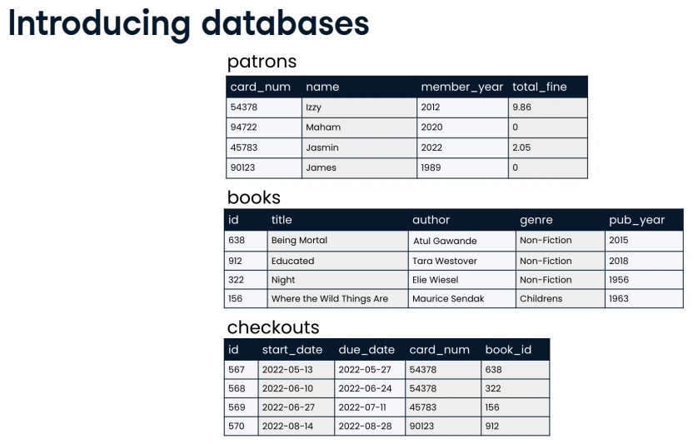

A database stores data. Let's imagine that we are in charge of storing and organizing data for a library. We might set up a database that holds information such as the data pictured here on patrons, books, and checkouts. This information is housed in objects called tables, with data organized into rows and columns. This database contains a patrons table, a books table, and a checkouts table.

**4. Introducing databases**

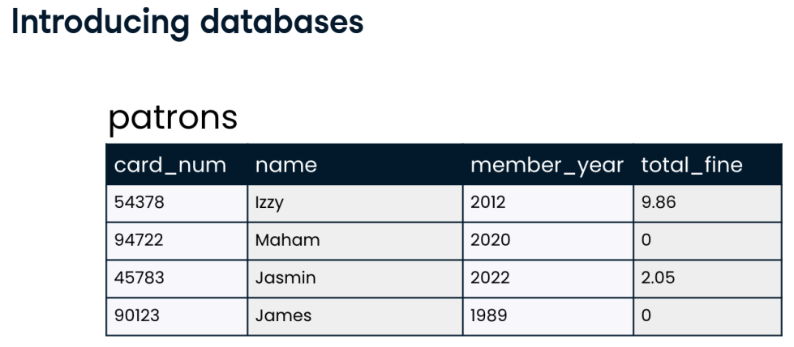A closer look at the patrons table shows that it stores various data about our library's patrons, like library card number, name, the year the patron became a library member, and the total overdue fines the patron owes our library.

**5. Relational databases**

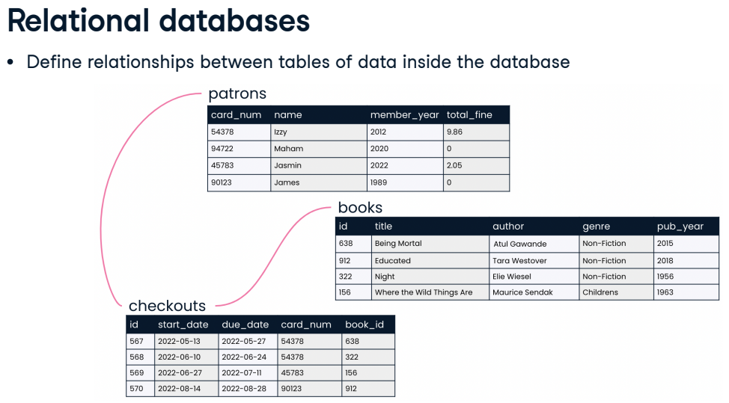A relational database defines relationships between tables of data inside the database. For example, each of our library patrons might each be associated with several checkouts. Through these relationships, we can draw conclusions about data housed in separate tables in the same database, and answer questions such as "Which books did James check out during 2022?" or "Which books are checked out most often?"

**6. Database advantages**

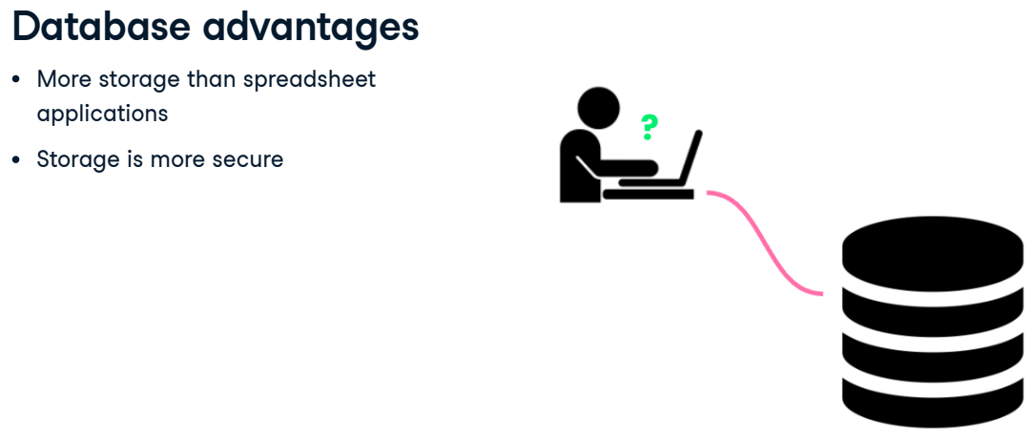These tables might look similar to the way data is organized in spreadsheet applications such as Excel or Google Sheets, but databases are far more powerful than spreadsheets. Databases can store much more data, and storage is more secure due to encryption.

**7. Database advantages**

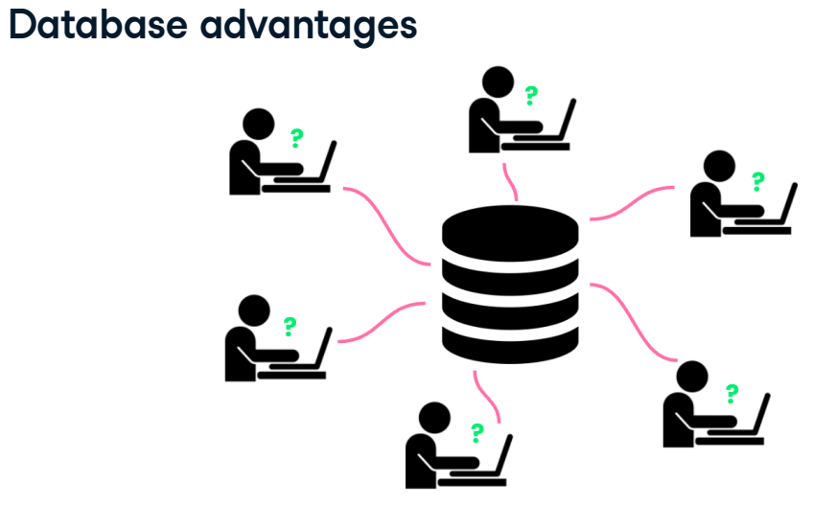Possibly the biggest advantage of a database is that many users can write queries to gather insights from the data at the same time. When a database is queried, the data stored inside the database does not change: rather, the database information is accessed and presented according to instructions in the query. Which leads us to the star of this show:

**8. SQL**

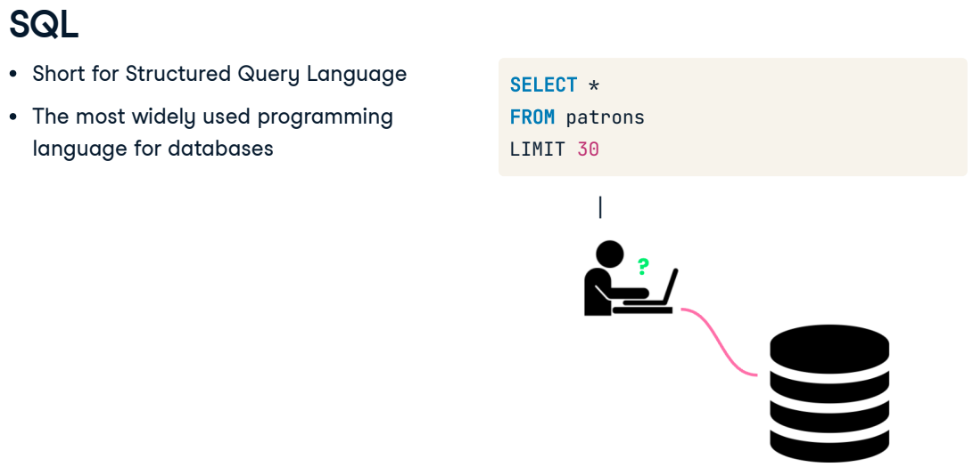SQL! SQL, or S-Q-L, is short for Structured Query Language. It is the most widely used programming language for creating, querying, and updating relational databases. Once we are familiar with the data we have and which table it is stored on, we can use SQL to begin writing queries to answer questions about our library -- more on that in Chapter Two.

**9. Let's practice!**

Alright, let's flex this newfound database knowledge in some exercises!

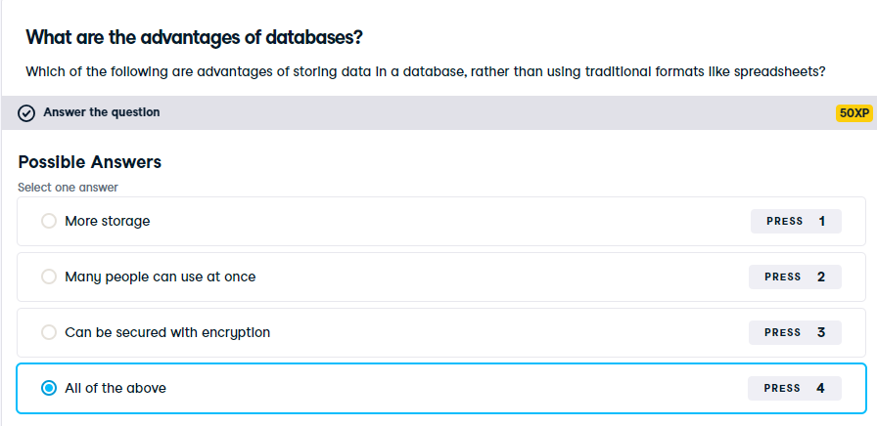

Well done! There are many advantages of databases, which is why much of the world's data is stored in them.

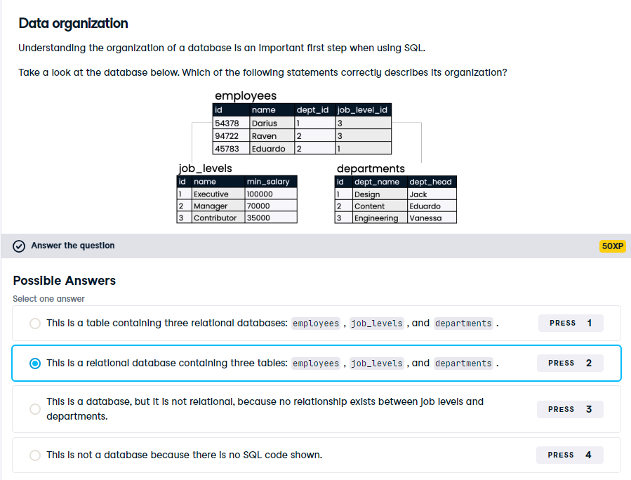

Well done! This is an example of how data in databases is organized into many tables.